Search engines-how to create

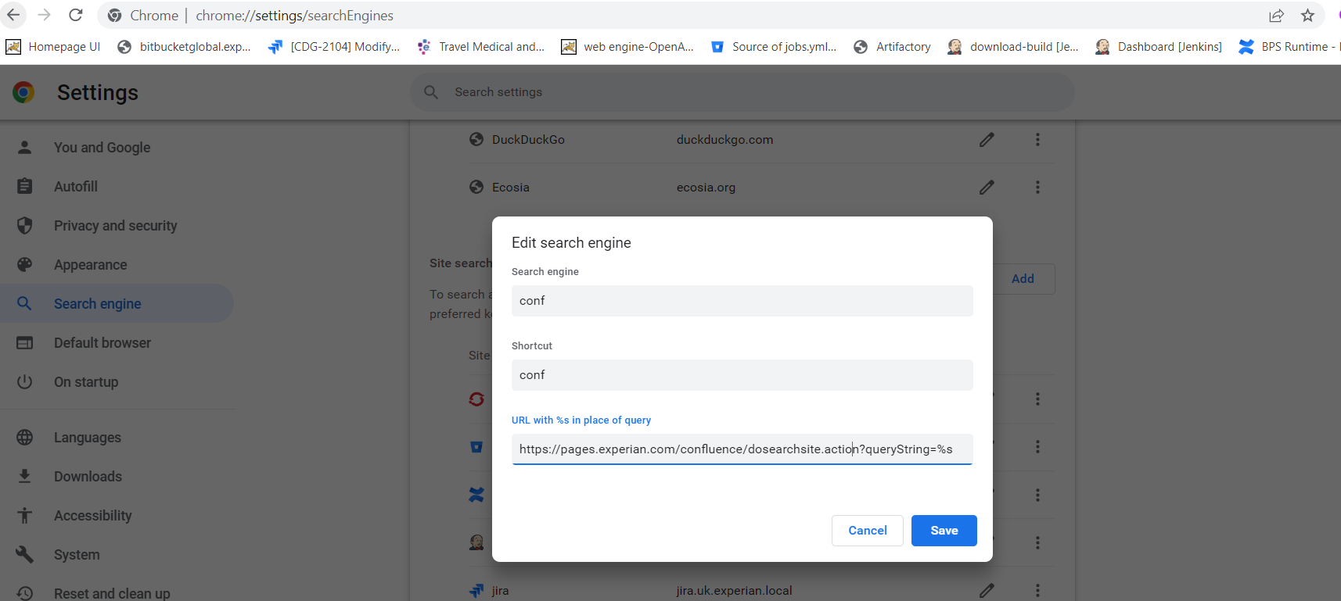

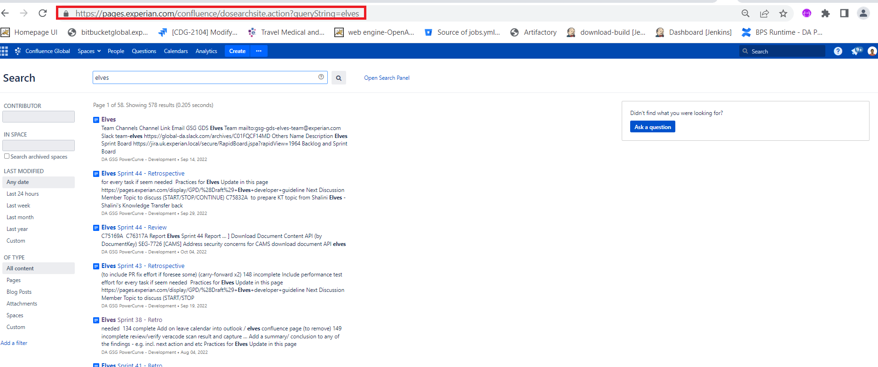

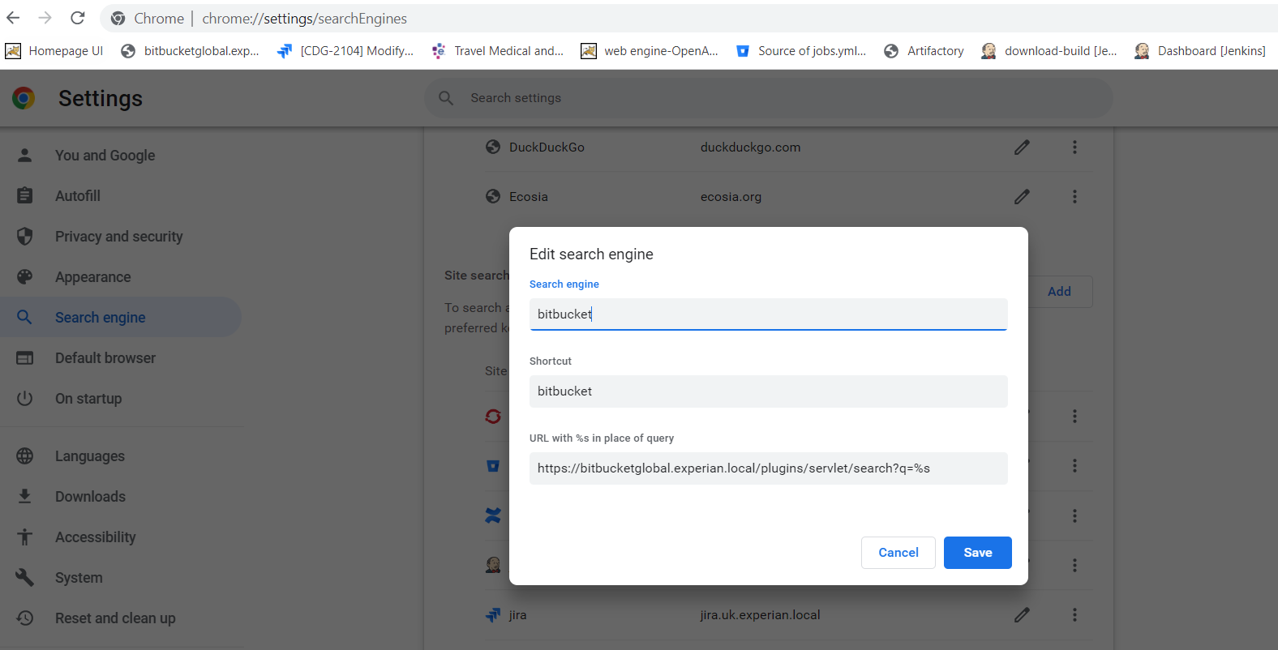

Go to chrome

Type bitbucket(which is the search engine keyword)

And press space which will give you option to search like below

